Planning Logic – Online Payments Fraud Detection using Machine Learning
This document briefly explains the sprint-wise planning logic of the Online Payments Fraud Detection project. The planning follows an Agile-based sprint model where each sprint focuses on a specific phase of the system.

Sprint 1: Data Collection and Data Preparation
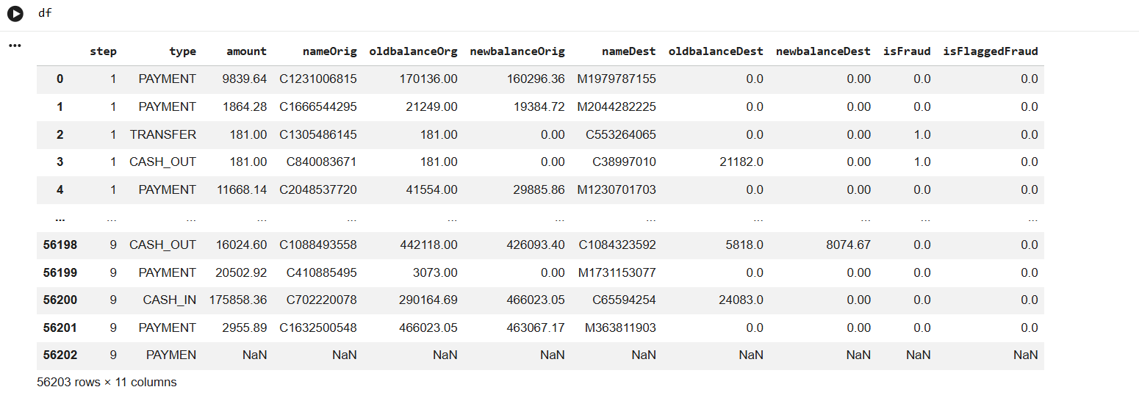
Epic 1: Data Collection
USN1 – Gathering Data :
The dataset is collected from a simulated real-world online transaction dataset, which represents mobile money transactions.
USN2 – Loading Data :
The collected dataset is loaded into the system using Python libraries such as Pandas for further analysis.
Epic 2: Data Preparation
USN3 – Handling Missing Values :
The dataset is checked for missing or null values, and appropriate cleaning techniques are applied.
USN4 – Creating Fields :
Relevant features required for fraud detection such as transaction amount and balance fields are selected.
USN5 – Handling Data Inconsistencies :
Inconsistencies such as incorrect balance updates are handled to improve model learning.

Sprint 2: Data Visualization

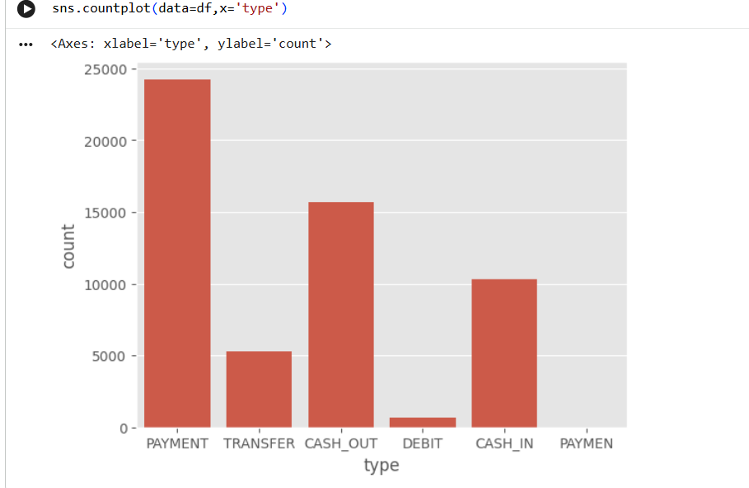
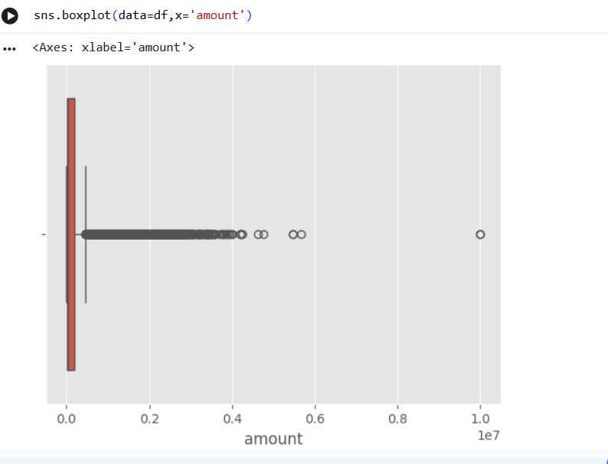
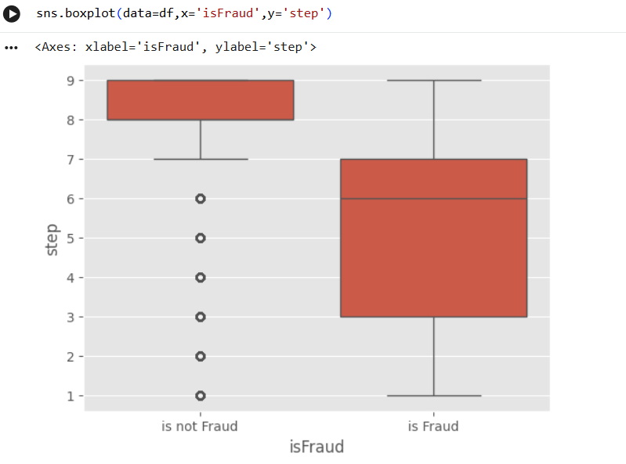
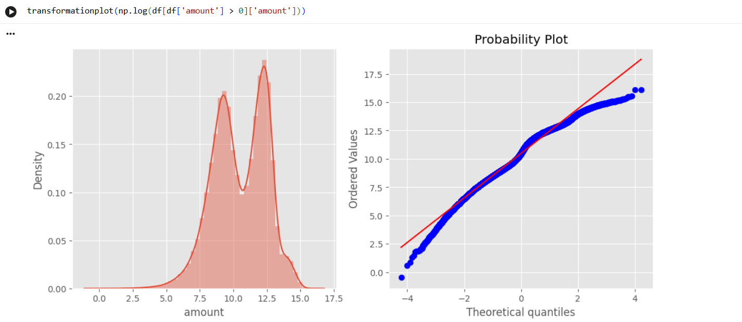
Epic 3: Data Visualization
USN6 – Bar Chart Visualization :
Bar charts are used to analyze transaction types and fraud distribution.
USN7 – Pie Chart Visualization :
Pie charts help in understanding the proportion of fraudulent and legitimate transactions.

Sprint 3: Model Development and Evaluation

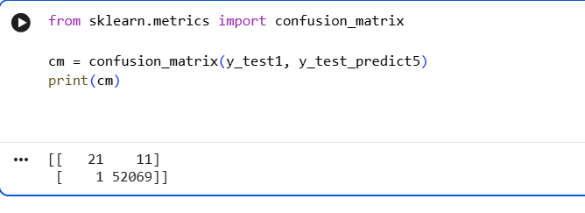
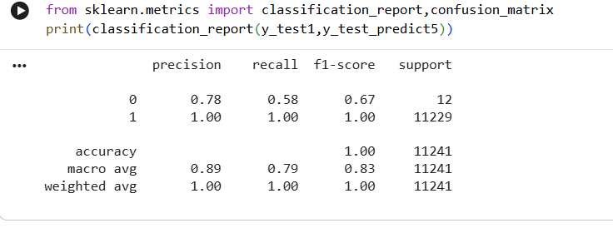

In this sprint, multiple machine learning models such as Decision Tree, Random Forest, and XGBoost are trained and evaluated. XGBoost is selected due to its superior performance.

Sprint 4: Application Development and Deployment
The trained model is integrated into a Flask web application. The application allows users to input transaction details and receive fraud predictions in real time. The final system is deployed on Render cloud platform.
